Station 6-
Go Fish!





Teacher’s Instructions:
STATION 6: Go Fish
Material :
- 1 set of plastified Appendix 6A-Go Fish Cards (cut the image and glue on a deck of playing cards).
- Optional

Modelling the activity with a group of 4 students is necessary before they are on their own in this station.

- Choose 4 students.
- Give 5 cards to each student. Put the rest of the cards face down on the table.
- The goal is to have as many packages of 4 cards (same images) as possible.
- To do so, ask one player for a card you possess in your hand.
- If the player does not have the cards, he says “GO FISH”. Then, you pick one card out of the lake. If the player has the card, he has to give you all the cards with that number or figure. Don’t forget to say: Thank you!
- Next player plays.
- Once you have a perfect match of 4 cards, display them in front of you.
- The game ends when there are no more cards left!
- The one who gets the most sets of 4 cards wins!

If students finish early, invite them to go to the station 7 “When I’m Finished” Station.
Students are ready to go to the next station.
Functional Language
Do you have…?

Yes, I do.

No I don’t! Go Fish!

It’s your turn.

It’s my turn.

Oh no! I don’t want to give the card to you!

Thank you !

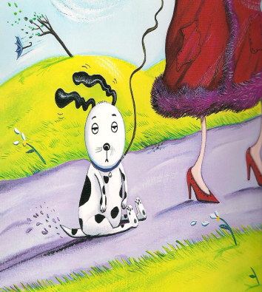
Station 6- Students Instructions

Material:
You need one deck of cards.

Instructions :

- Give 5 cards per student. Put the rest of the cards face down on the table.

- The goal is to have as many packages of 4 cards (match) as possible.

- To do so, ask one player for a card you possess in your hand.

- If the player does not have the cards, he says “GO FISH”. Then, you pick one card out of the lake.

- If the player has the card, he has to give you all the cards with that number or figure. Don’t forget to say: Thank you!

- Next player plays.

- Once you have a perfect match of 4 cards, display them in front of you.

- The game ends when there are no more cards left!

- The one who gets the most sets of 4 cards wins!
Functional Language
Do you have…?

Yes, I do.

No I don’t! Go Fish!

It’s your turn.

It’s my turn.

Oh no! I don’t want to give the card to you!

Thank you !

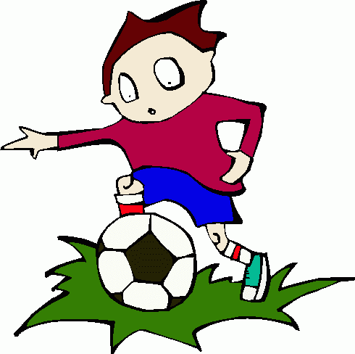  playing soccer | playing soccer | playing soccer | playing soccer
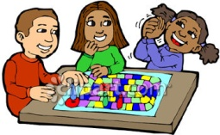  playing boardgames | playing boardgames | playing boardgames | playing boardgames
  watching TV | watching TV | watching TV | watching TV
going for a walk | going for a walk | going for a walk | going for a walk
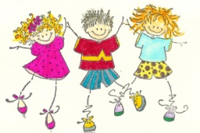  dancing | dancing | dancing | dancing
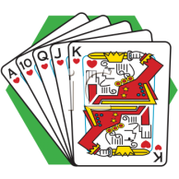  playing cards | playing cards | playing cards | playing cards
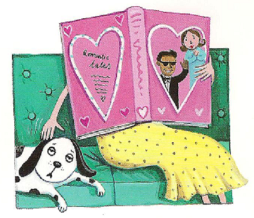  reading | reading | reading | reading
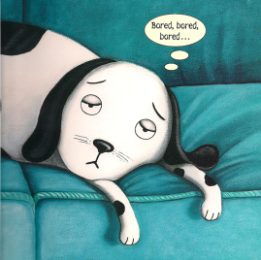  Bill | Bill | Bill | Bill
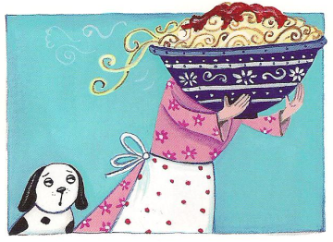  cooking | cooking | cooking | cooking
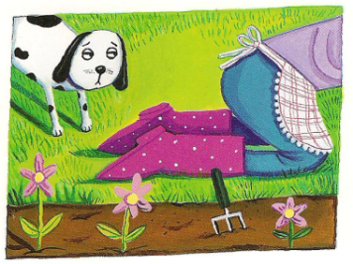  gardering | gardering | gardering | gardering
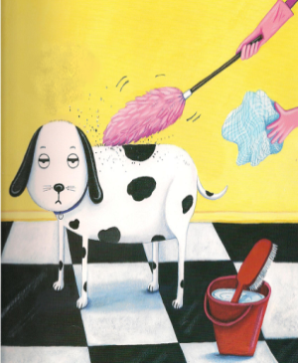  clearing | clearing | clearing | clearing
  aliens | aliens | aliens | aliens
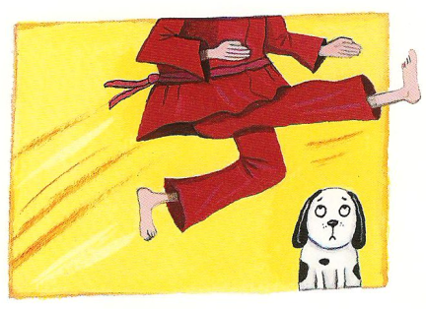  Kung fu | Kung fu | Kung fu | Kung fu

