Appendix 7

My Lost and Found Mini-book

Writing a personalized text

Instructions
1.Write your name.  | 2. Choose a colour and a description. 
  Colour | Description
  - pink  - grey  - black  - white  - yellow | - round  - cute
3. Choose an action word.  It’s my turn.  I am paying attention!    - crying  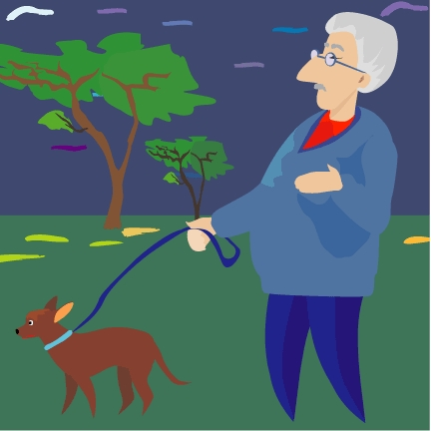  - wandering    - sleeping    - hopping    - waddling | 4. Repeat colour and description from number 2.      5. Draw the pictures in the boxes.  6. Cut out your mini-book.  7. Present your mini-book to a friend or a family member.  
Writing My Mini-book
1.  I’ve Lost My Cat  By: ____________________________  (1) | 2.  I’ve found your cat all  _______________ , ____________ and  (2-colour) (2-colour)  ____________________________.  (2-description)
3.  He was  _______________________________.  (3) | 4.  I’ve found my cat, so  _______________ , ____________ and  (2-colour) (2-colour)  ____________________________. Good night.  (2-description)

