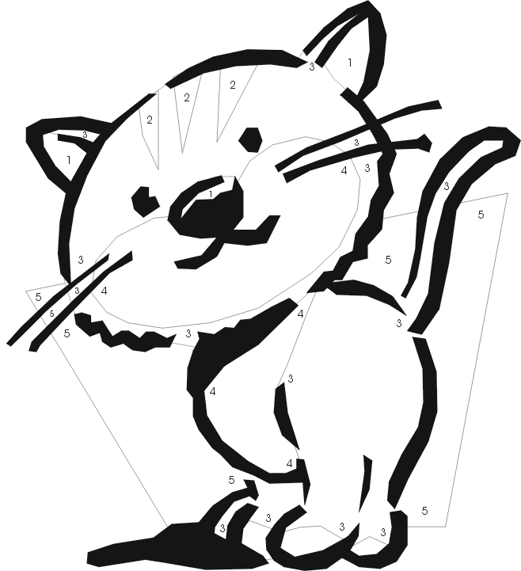
Name :_____________________

Colour by numbers

1- pink
2-black
3. grey
4. white
5. yellow

Name :_____________________
1- pink
2-black
3. grey
4. white
5. yellow

Colour by numbers

