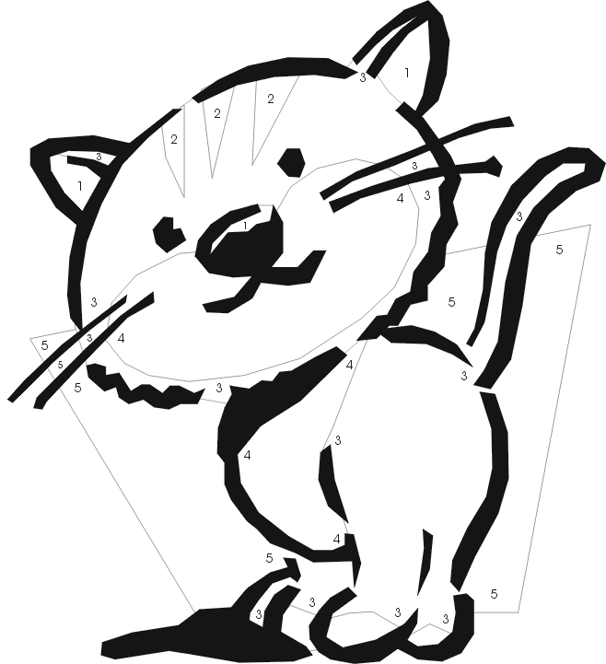
Name :_____________________

Colour by numbers

1- pink
2-black
3. grey
4. white
5. yellow

Name :_____________________

Colour by numbers
1- white
2-black
3. yellow
4. pink
5. grey
Name :_____________________
It = animal
Write a description of your cat. (Ex.: It has a pink nose. / My cat has a pink nose.)
- _______________________________________________________________________.

- _______________________________________________________________________.

- _______________________________________________________________________.

- _______________________________________________________________________.

- _______________________________________________________________________.

- _______________________________________________________________________.

- _______________________________________________________________________.

Choose your colours.
ears
1- ______________
2-______________
3-______________
4-______________
5-______________
body
paws
face
nose
tail
stripes

