 | Learning and Evaluation Situation  English as a Second Language, Core Program
 | Secondary 1

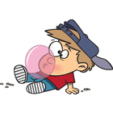
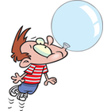
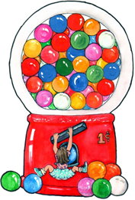

Student Booklet
Name: Date:

Group: _______________

Overview of the learning and Evaluation Situation

Activity 3

Video How it's Made: Bubble Gum

Watch the video and answer questions

Activity 2

Timeline:
A Brief History of Bubble Gum

Read the text and complete a timeline

Activity 4

Packaging:

Match the images with the correct words

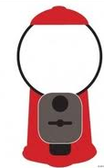

Activity 1

The Origin of Gum:

Read the text and answer questions
GUM:
Ageless Candy

Why do people enjoy chewing gum?

Activity 5

Benefits of Chewing Gum:

Determine the benefits

Introductory Task

Brainstorming:

Write what you know about gum

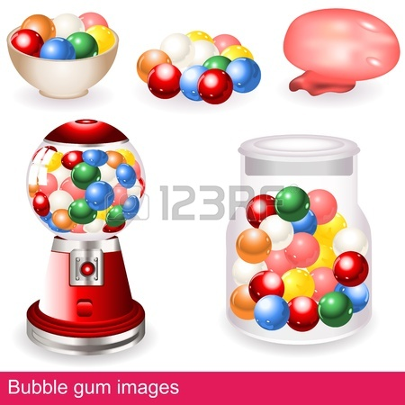
Final Task

Poster:

Create a poster of a new brand of bubble gum

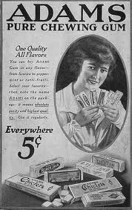
The Origin of Gum

Got the urge to chew? Maybe you should go out and rip off a nice chunk of car tire. Not your idea of a tasty treat? A nice chunk of chewing gum is probably more like it. Did you know, there is a link between car tires and chewing gum?

Natural Gum is Discovered
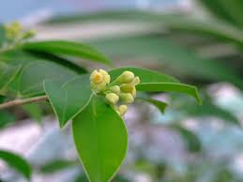
The history of gum begins thousands of years ago, when prehistoric men and women chewed on “mastiche”, the resin from the mastic tree. Later, Greek women favored chewing mastic gum to clean their teeth and sweeten their breath. In South America, people enjoyed “chicle”, a natural gum that comes from the Sapodilla tree.

The First Chewing Gum
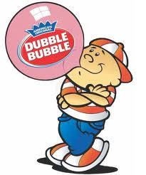
In 1869, a Mexican general, Antonio Lopez de Santa Anna, hired New York inventor Thomas Adams to develop a new form of rubber. He thought that he could combine chicle with rubber and invent a new material for making tires. His experiments were disastrous! Adams then had another idea: if people couldn’t drive on his “chicle” maybe they could chew on it! He succeeded in producing the first modern chewing gum, named Adams New York N° 1.

The First Bubble Gum
In 1906, the first bubble gum called Blibber-Blubber was invented but it never sold. It was so sticky that if it popped on your face, it was almost impossible to remove! It was in 1928 that Walter Diemer accidentally invented Dubble Bubble, the first successful bubble gum. One day, he created the perfect gum recipe and added pink coloring because it was the only color he had.

So, now that you know where it comes from, will you keep on chewing? Hopefully not in class, there are already too many pieces of gum stuck under your desk ! ! !

Text adapted from No-sweat Bubble tests © Scholastic Teaching Resources
http://en.wikipedia.org/wiki/Chewing_Gum
ACTIVITY 1 THE ORIGIN OF GUM
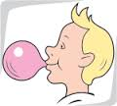

Answer the following questions:

- What is “mastiche”?
____________________________________________________________________________________

- Why did Greek women chew gum? (2 reasons)
____________________________________________________________________________________

- Where does the “chicle” come from?
_____________________________________________________________________________________

- When was the first chewing gum invented? ________________________________________________

- What is the name of the first chewing gum? _______________________________________________

- Blibber-Blubber was invented in what year? ______________________________________________

- What was the problem with this first bubble gum?
_____________________________________________________________________________________

- Who invented Dubble Bubble? In what year? ______________________________________________

- Why is Dubble Bubble pink?
_____________________________________________________________________________________

- Where do you throw your piece of gum after chewing it?
_____________________________________________________________________________________

- Write one piece of information you learned in this text.
_____________________________________________________________________________________

- What is your favorite brand of gum? Which flavor do you prefer? Why?
_____________________________________________________________________________________

- Do you know how to blow a bubble?
_____________________________________________________________________________________

ACTIVITY 2 Timeline: A BRIEF HISTORY OF BUBBLE GUM

Read the text on the history of bubble gum. Complete the timeline with the correct information.

The History of Bubble Gum

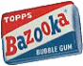
Inventions are rarely successful the first time around. Frank Henry Fleer discovered this when he tried to make bubble gum, it was too sticky and tasteless. This problem was solved when William Wrigley Jr. helped Fleer. Mister Wrigley and Fleer had the idea to add mint and fruit extracts. Later, another inventor discovered the perfect bubble gum recipe during an experiment. At the end of the Second World War, the brand name Bazooka Bubble Gum was created by the Topps Candy Company in the United States of America.

1914
1945

1950
1900

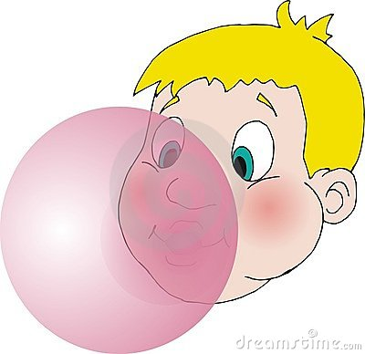
1906
1928

activity 3 HOW IT’S MADE: BUBBLE GUM

Watch the video and then answer the questions.

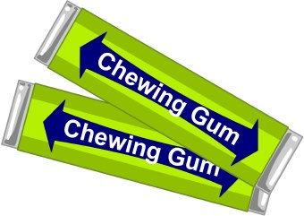
Use the words in the box to help you answer the questions.

Use the words in the box to help you answer the questions
Second | Plastic | Pink
20 | Flavor | Rubber
Dentist | 900 | Resin
1869 | Color

- The Ancient Greeks used to chew ______________ from trees which is similar to chewing gum.
- In which year was chewing gum invented in the U.S.A.? ________________________
- What is the occupation of the man who invented gum? _________________________
- Name two things that make the gum base chewy. _____________ ______________
- Name two things that are added to the gum in the mixer. ___________ ___________
- For how long do they mix the sugar? __________________________________minutes
- How much time does it take to wrap the bubble gum? Less than one _____________
- How many pieces of bubble gum can the machine wrap in one minute? __________
- Bubble gum is usually which color? _________________________________________

activity 4 PACKAGING

Match the different packages of gum with the corresponding vocabulary words

Gum Ball |  | Candy Gum | Center-filled Gum
Shredded Gum |  | Chiclet Gum | Cut and Wrap Gum
Powdered Gum |  | Stick Gum | Ribbon Gum
Tube Gum

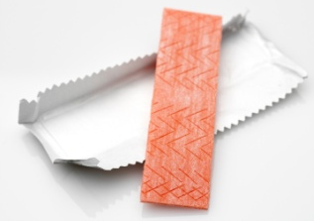
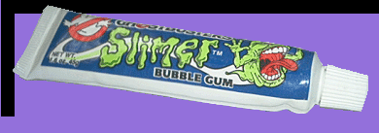
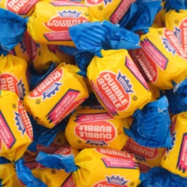

4-
- 8-
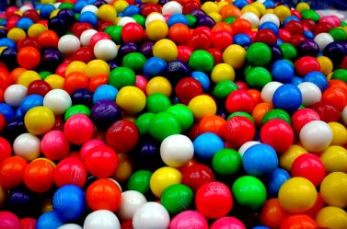

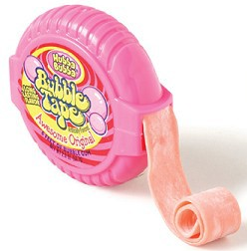
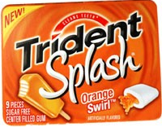

5-

2-

9-

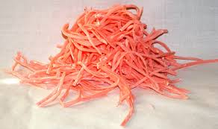
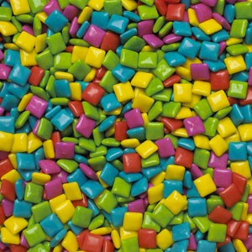

6-

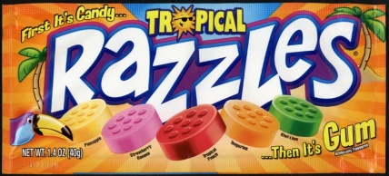

- 10-

7-

activity 5 BENEFITS OF CHEWING GUM

The following information presents facts about gum. Some facts are also benefits of chewing gum. Read each text and put a check mark (√) in the box that is a benefit.
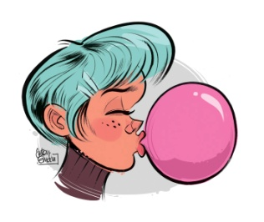
After meals when it is not always convenient to use a tooth brush, chewing gum helps keep teeth clean.
After meals when it is not always convenient to use a tooth brush, chewing gum helps keep teeth clean.
1
Do you know why gum is pink?
The color of the first successful bubble gum was pink because it was the only color the inventor had left. The color « stuck » and today bubble gum is mostly pink.
2
Tips for getting gum to unstick from clothing: try scraping off any excess gum with a butter knife then rubbing the area with ice until the remaining gum rolls off into a ball.
3
For smokers, chewing gum can stop you from lighting a cigarette.
4
Gum helps us concentrate on the task at hand, many car and truck drivers find that chewing gum is valuable and keeps them alert.
5
Chewing gum refreshes the mouth and throat and sweetens the breath.
6
Can you really remove gum from your hair with peanut butter? It has been proven that if you spread a small amount of peanut butter between your fingers and the gum it will disperse enough so that you can remove it.
7

The largest bubble ever blown was 23 inches in diameter. The record was set on July 19th, 1994 by Susan Montgomery Williams of Fresno, California.
Did you know that there are more than 1000 varieties of gum manufactured and sold in the United States?
8
When you fly
in an airplane,
chewing gum reduces
ear popping.
9
Gum is banned in Singapore since 1992 because it was becoming a danger when stuck in the sliding doors of underground trains.
10
Cinnamon, spearmint and peppermint are the most popular flavors of gum!
11
Chewing gum relaxes out nerves and muscles and eases tension in many everyday situations.
12
Chewing gum often satisfies the desire for a snack, yet it is low in calories – averaging less than 10 per stick.
14

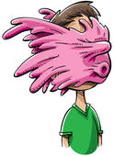

13
Text adapted from Bubble Gum main page http://library.thinkquest.org/J0113191/facts.html
Introductory activity BRAINSTORMING
TRODUCTORY TASK
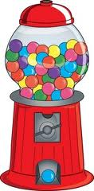

\\adm-cad\cad\Usagers\Res-ANJ-StL-ES\Annexe-PAT\Josée_DeChamplain\Golini_Viviane\E-S\Gum Ageless Candy\Student Booklet_14-01-30.docx

