

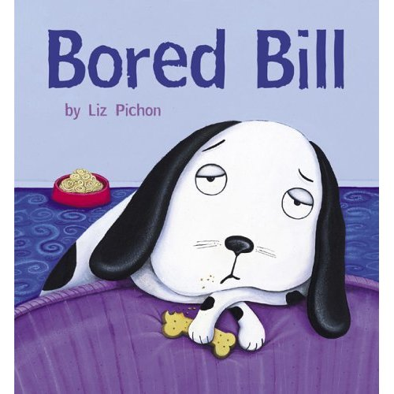

©Liz Pichon

Teacher’s Guide
Learning and evaluation situation (class and home)
Cycle 1-Grade 2
Elementary
Link with program

BAL: Citizenship and Community Life

CCC: Cooperates with Others

ESL Competencies:

- C1- To act on Understanding of Texts
- C2- To Communicate Orally in English

Links with Progression of Learning:
The symbol → used in the Progression of Learning (POL) chart for Cycle One has a different connotation from the same symbol used in the general legend of the POL. It signifies that students are becoming aware of new knowledge while developing the competencies To act on understanding of texts and To communicate orally in English.

- Joins in during playful choral responses
- Describes people/characters (Bill, Mrs. Pickle, the aliens)
- Uses basic expression of courtesy
- Uses cheers
- Uses expressions during pair work
- Uses expressions containing action words
- Uses vocabulary related to objects and people
- Builds personal repertoire of words and short expressions when joining in to perform song and story
- Repeats, rehearses, regroups, integrates and assimilates words and expressions
- Make use of human resources
- Take risks
- Orally identifies characters, actions, objects, places and main events
- Discovers cultural elements through a book, song and video.

Copyrights to the images:
Dear Isabelle,
Many thanks for your email. We would be happy to grant permission for you to use "Bored Bill" as described below, based on the understanding that the book will only be used in this intended way.
Please ensure you provide the following credit:
Bored Bill, text and illustrations copyright © Liz Pinchon 2005. Published by Little Tiger Press, London.
Kind regards,

Mara Alperin
Editorial Assistant
Little Tiger Press www.littletigerpress.com
Hello,
I am a consultant in English second language at the elementary level. I am developing a project for grade 2 students in Québec, Canada using the book Bored Bill by Liz Pichon. I would like to know if I can use images from the book to illustrate the different activities that I am proposing to the students. These students are learning a second language and need to have visual support to better understand the story. Each picture used would have the copyright sign with the author’s name and publishing house.

Would you please grant us the rights for classroom purposes only?

Material needed to read the book:
- Book Bored Bill by Liz Pichon
- Stations 1-7 (other material is needed and mentioned in each station.)
- Garden tool
- Apron
- Duster
- Dog leash-collar + stuffed dog (preferably black and white)
- Green goo recipe: bowls, water, green food coloring, white craft glue, liquid starch or Borax powder, spoons, empty pill bottles (available at drug store or ask students to bring some).

Optional props

Material needed to make Green Goo (Alien food):
- Book Bored Bill by Liz Pichon
- Goo/slime recipe: bowls, water, green food coloring, white craft glue, liquid starch or Borax powder, spoons, empty pill bottles (available at drug store or ask students to bring some), labels (appendix 3).
- Method 1 video and recipe (Excellent) (with liquid starch for clothes)
  - http://www.sciencebob.com/experiments/slime2.php

- Method 2 video and recipe (Excellent) (with borax)
  - http://www.sciencebob.com/experiments/polymer.php

Green Jello could be used instead.

Playing Go Fish beforehand with students is helpful. A Go Fish activity is provided if this hasn’t been done in class before starting with this project.

Preparation

- Teacher elicits students’ prior knowledge by asking the following questions:
  - Do you have a pet? Which ones? Names? Breed? Ask students if they have ever lost a pet (or know someone who lost one).
- Introduce song: Oh Where, Oh Where Has my Little Dog Gone?
- Teacher invites students to sing-along. Handout lyrics (Appendix TG 1) to students and they glue it in their scrapbook/duo-tang.
CD-song
Appendix TG1-Lyrics

- Teacher shows book Bored Bill to students. Teacher asks students these questions:
  - What is the title of the book? What do you think will happen in the book? Does it ever happen sometimes that you are bored? What do you do when you are bored? How do you express boredom? Do you sigh? Do you roll your eyes? Do you sulk?
  - Teacher shows to students how to sigh, roll their eyes, and sulk.

- Teacher tells students that while s/he reads the book, every time they hear the word “BORED” they are to sigh and roll their eyes!
Book
Appendix TG2-Posters
Optional props
CD-song

- Teacher stops reading the story up to where Mrs. Pickle is rescued by the fireman. Teacher asks students:
“Now you know that Mrs. Pickle loves her dog. She can’t find him anywhere. Don’t you think she’s worried about him? Do you think she would like us to sing the song to help her find her dog? Let’s sing together.”

- Sing song together.

- Teacher continues reading the story to the end. Teacher asks questions:
  - Did you like the book?
  - What is your favourite part?
  - Would you like eating the Alien food?
  - Would you like to go in a spaceship?
  - Which Alien is the funniest?
  - Does Bill have fun with his new friends?
  - Is Mrs. Pickle happy to see Bill?
  - Is Bill happy to see Mrs. Pickle?
  - Do you know Kung Fu moves? Would you like to try some?
  - Is Bill still bored at the end of the story?
  - What does Bill like to do at the end of the story?
  - …
- Possibility to evaluate: C1: To act on understanding of Texts

Making Green Goo/Slime
- Teacher shows video on how to make slime. (Alien food).

  - Method 1 video and recipe (Excellent) (with liquid starch for clothes)
http://www.sciencebob.com/experiments/slime2.php

  - Method 2 video and recipe (Excellent) (with borax)
http://www.sciencebob.com/experiments/polymer.php

- Teacher makes slime in front of whole class and gives out samples of “Alien food” to each student in a pill bottle to bring home.

- Place labels on pill bottle.
Goo/slim recipe: bowls, water, green food coloring, white craft glue, liquid starch or Borax powder, spoons, empty pill bottles (available at drug store or ask students to bring some) and labels.
Appendix TG3-labels

Kung Fu Dance

- Watch the video on this link http://www.youtube.com/watch?v=6DLPSU3PTNA or DVD/TV
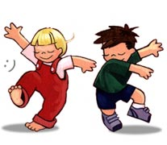
- Dance with the students!

Stations 1-7

Model each station with students prior to students being on their own.

- Place students in teams of 3-4. Class should be set up in 7 different stations. At each station, a folder is identified with the station number and all the necessary material is placed for the students to do the tasks. When students are finished earlier with one station, ask them to go to the “When I’m Finished” station to do the 4 winding-down moment activities.
Stations 1-7 folders
Possibility to evaluate C1: To act on understanding of Texts
C2: To communicate orally in English

Consult each station folder for instructions and materials.

Carrying out the task

Students work in stations.

Assimilation and Transfer

- Teacher reads the book once again and stops at when Mrs. Pickle lost her dog. Teacher asks students if they have ever seen a lost poster in their area. (on a post, at the store, in the newspaper, on a mailbox, etc.)
- Teacher should show the students a sample of a lost poster of an animal. (Check on Internet)
- Teacher asks this question:
  - What do you see on a lost poster?
  - Write these possible answers on the board: picture, phone number, name of pet, colour, male-female, age, size,…
- Teacher hands out the lost poster and tells the students that Mrs. Pickle needs help to find Bill.
- Teacher asks students to complete the poster with what they learned about Bill, the story and the stations.
Appendix TG4: Lost Dog poster

Optional/extra activities to do:
- Have each student bring Bill home in a bag with a disposable camera. Take a picture with Bill of what they like or dislike to do at home. When all students have brought Bill home, develop the film and give the pictures to the students as a souvenir.
- Have a search party to find Bill in the school.
- Have a tea-party to celebrate Bill coming home.
- Invite students to look out for lost pets in their community.
- Invite a grand-mother playing the role of Mrs. Pickle with a real dog. Have her sign autographs.

Notes:

Appendix TG1-Lyrics
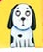  Oh where, oh where  Has my little dog gone?  Oh where, oh where  Can he be?  With his ears cut short  ?  And his tail cut long,  Oh where, oh where  ?  Can he be? | Oh where, oh where  Has my little dog gone?  Oh where, oh where  Can he be?  With his ears cut short  ?  And his tail cut long,  Oh where, oh where  Can he be?  ?
Oh where, oh where  Has my little dog gone?  Oh where, oh where  Can he be?  With his ears cut short  ?  And his tail cut long,  ?  Can he be? | Oh where, oh where  Has my little dog gone?  Oh where, oh where  Can he be?  With his ears cut short  ?  And his tail cut long,  Oh where, oh where  ?  Can he be?
Oh where, oh where  Has my little dog gone?  Oh where, oh where  Can he be?  With his ears cut short  And his tail cut long,  ?  Oh where, oh where  ?  Can he be? | Oh where, oh where  Has my little dog gone?  Oh where, oh where  Can he be?  With his ears cut short  ?  And his tail cut long,  Oh where, oh where  ?  Can he be?

Appendix TG2-Posters
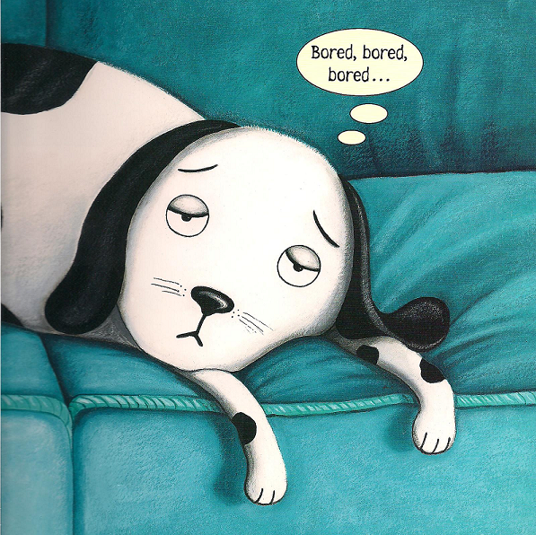

bored
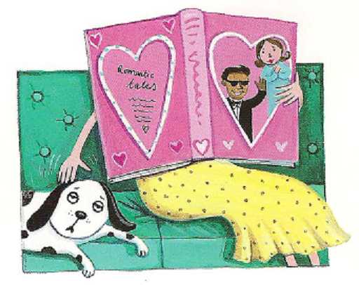

reading

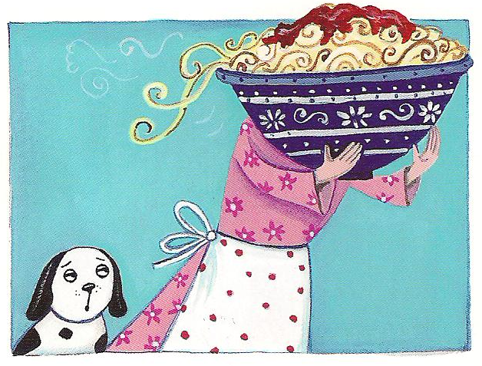

cooking

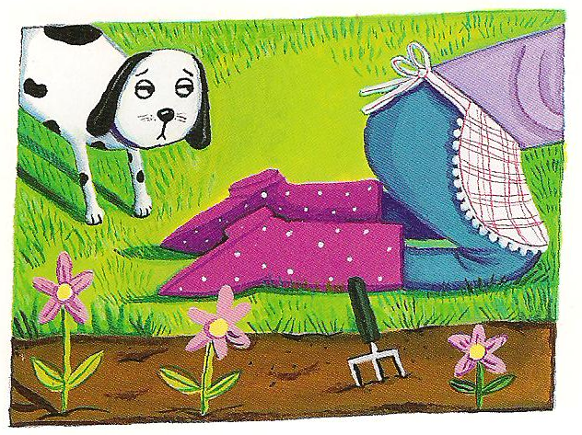

gardening

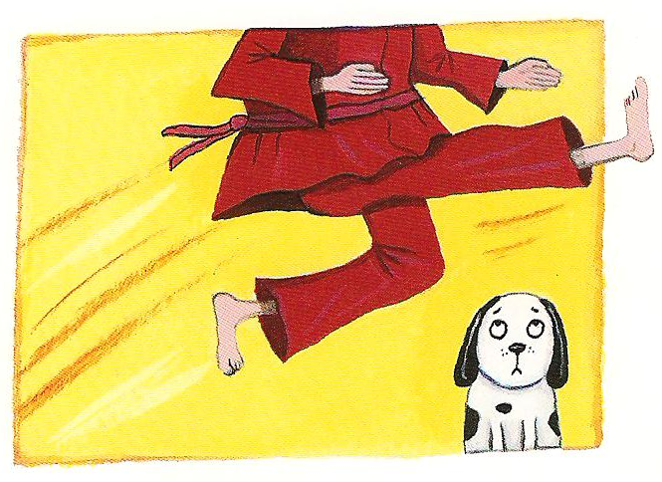

kung fu
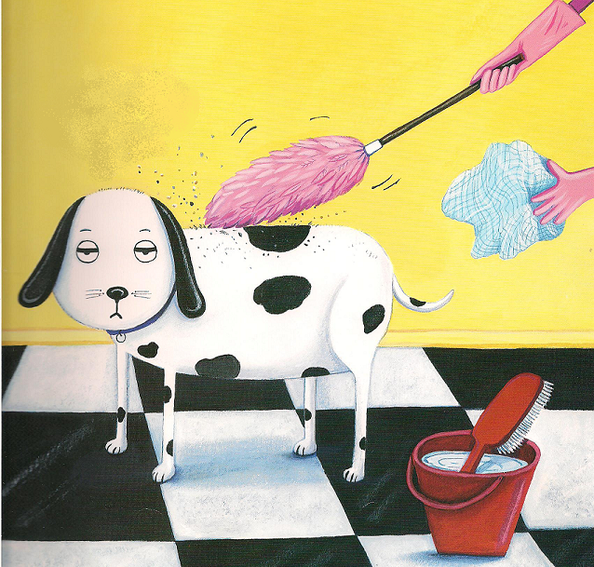

cleaning

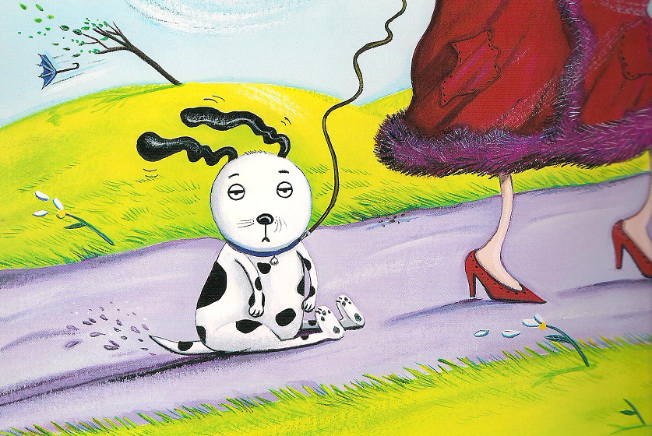

going for
a walk
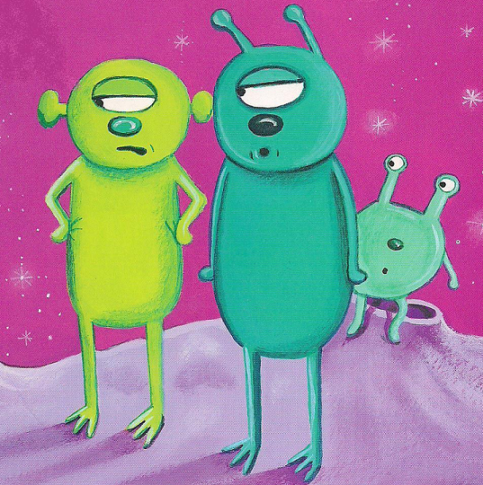

aliens
Appendix TG3- Alien Food Labels to put on pill bottles AVERY 5160
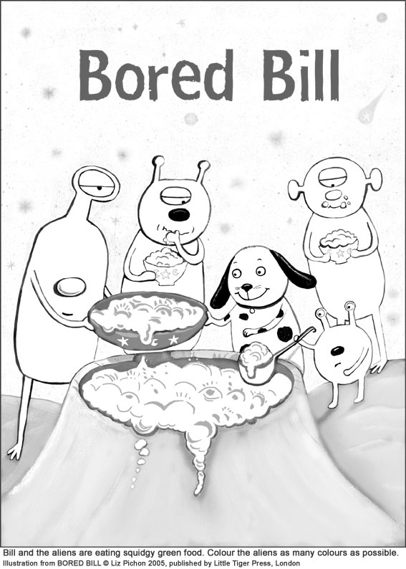  CAUTION!  ALIEN FOOD!  DO NOT EAT. |  | CAUTION!  ALIEN FOOD!  DO NOT EAT. |  | CAUTION!  ALIEN FOOD!  DO NOT EAT.
CAUTION!  ALIEN FOOD!  DO NOT EAT. |  | CAUTION!  ALIEN FOOD!  DO NOT EAT. |  | CAUTION!  ALIEN FOOD!  DO NOT EAT.
CAUTION!  ALIEN FOOD!  DO NOT EAT. |  | CAUTION!  ALIEN FOOD!  DO NOT EAT. |  | CAUTION!  ALIEN FOOD!  DO NOT EAT.
CAUTION!  ALIEN FOOD!  DO NOT EAT. |  | CAUTION!  ALIEN FOOD!  DO NOT EAT. |  | CAUTION!  ALIEN FOOD!  DO NOT EAT.
CAUTION!  ALIEN FOOD!  DO NOT EAT. |  | CAUTION!  ALIEN FOOD!  DO NOT EAT. |  | CAUTION!  ALIEN FOOD!  DO NOT EAT.
CAUTION!  ALIEN FOOD!  DO NOT EAT. |  | CAUTION!  ALIEN FOOD!  DO NOT EAT. |  | CAUTION!  ALIEN FOOD!  DO NOT EAT.
CAUTION!  ALIEN FOOD!  DO NOT EAT. |  | CAUTION!  ALIEN FOOD!  DO NOT EAT. |  | CAUTION!  ALIEN FOOD!  DO NOT EAT.
CAUTION!  ALIEN FOOD!  DO NOT EAT. |  | CAUTION!  ALIEN FOOD!  DO NOT EAT. |  | CAUTION!  ALIEN FOOD!  DO NOT EAT.

Appendix TG4-Lost Dog Poster
Lost Dog

picture
Name :_____________________
Owner :____________________
Colour : ____________and _________________
Likes : _________________________
Dislikes : _________________________


Please call if you find this dog. Mrs. Pickle misses him. 123-456-7890
Missing

