  Life is an
  open book.
  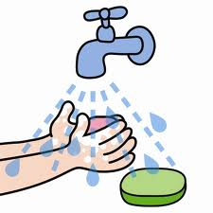
  Before reading
  my book, I wash
  my hands.
  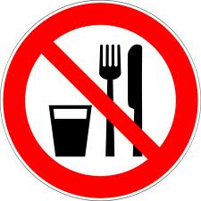
  I don’t eat or drink
  while I’m reading.
  I take good care of my book
  and turn the pages
  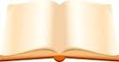
  slowly.
  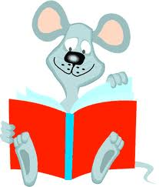
  I complete
  the activities.
  
  I make sure all the
  material is back
  in the blue folder.
  Life is an
  open book.
  Before reading
  my book, I wash
  my hands.
  I don’t eat or drink
  while I’m reading
  I take good care of my book
  and turn the pages
  slowly.
  I complete
  the activities.
  I make sure all the
  material is back
  in the blue folder.
  Life is an
  open book.
  Before reading
  my book, I wash
  my hands.
  I don’t eat or drink
  while I’m reading.
  I take good care of my book
  and turn the pages
  slowly.
  I complete
  the activities.
  I make sure all the
  material is back
  in the blue folder.

