Station 3-
Memory Game




Teacher’s Instructions

STATION 3: Memory Card

- 1 set of plastified Appendix 3A-“Memory game cards”
- 1 copy of Appendix 3B-Correction key

- Ask the students to place the cards facing down.
- Taking turns, students match the word with the image.
- Students with the most pairs win.
- Students can play more than once if they have time.

If students finish early, invite them to go to the station 7 “When I’m Finished” Station.

Students are ready to go to the next station.

Station 3- Student Instructions

- Place all the cards face down.
- Taking turns, turn 2 cards.
- If the image and word match, you keep it.
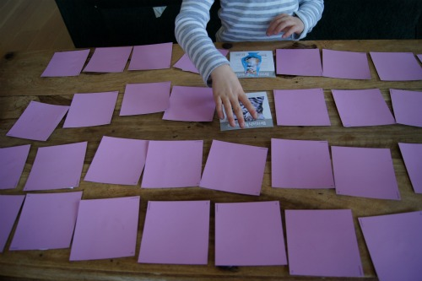

Example:



playing soccer
=
+

