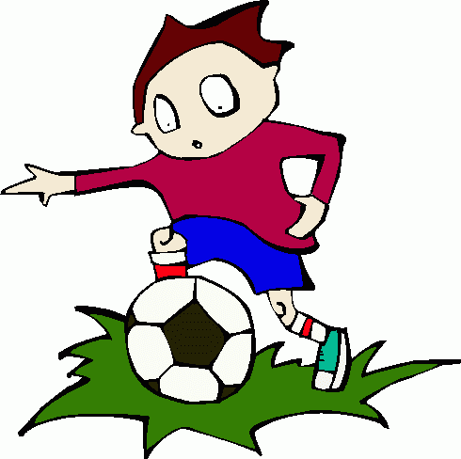  playing soccer | playing soccer | playing soccer | playing soccer
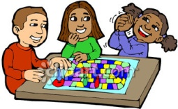  playing boardgames | playing boardgames | playing boardgames | playing boardgames
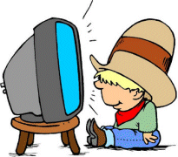  watching TV | watching TV | watching TV | watching TV
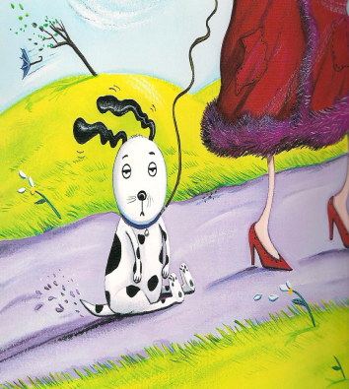  going for a walk | going for a walk | going for a walk | going for a walk
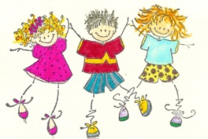  dancing | dancing | dancing | dancing
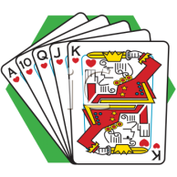  playing cards | playing cards | playing cards | playing cards
  reading | reading | reading | reading
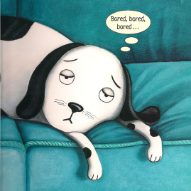  Bill | Bill | Bill | Bill
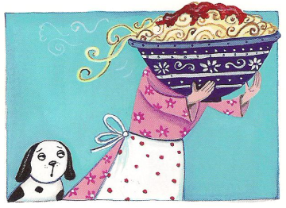  cooking | cooking | cooking | cooking
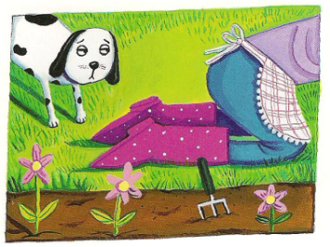  gardening | gardening | gardening | gardening
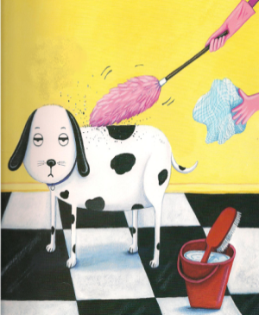  cleaning | cleaning | cleaning | cleaning
  aliens | aliens | aliens | aliens
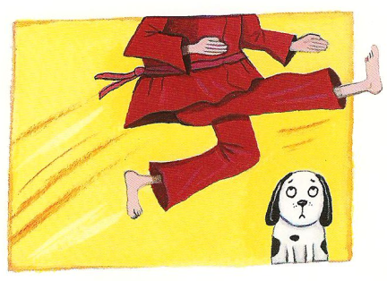  Kung fu | Kung fu | Kung fu | Kung fu

