Station 4-
Sequencing
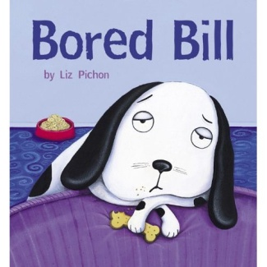



Teacher’s Instructions

STATION 4: Sequencing
Material :
- 1 plastified Appendix 4A-“Remember Bill’s Story?”
- 1 envelope with plastified Appendix 4B “Sequencing” (cut in strips)
- 1 Appendix 4C-correction key

- Students work together to put the story back in order.
- When finished, one student asks the teacher for the correction key .
- Students correct together and make changes if necessary.

If students finish early, invite them to go to the station 7 “When I’m Finished” Station.

Students are ready to go to the next station.

Station 4-Students Instructions

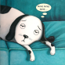

Bill is bored.
1


2

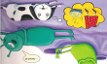
Bill is bored and misses Mrs. Pickle.

3

4

5

6

7

8

9

Appendix 4A- Remember Bill’s story? Put the events in order.


1
Bill is bored.

2

3
4

5

6
7

8

9

Appendix 4B-strips of sequencing events (to cut and plastify)
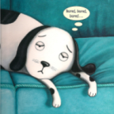
Bill is bored.
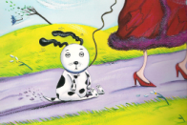
Bill goes for a walk with Mrs. Pickle.
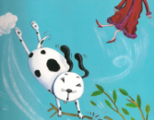
The wind lifts Bill and Mrs. Pickle from their feet.
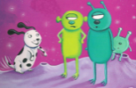
Bill lands on a strange purple planet
and meets aliens.
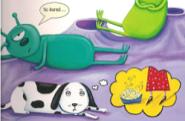
Bill is bored and misses Mrs. Pickle.
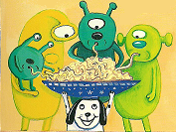
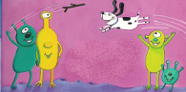
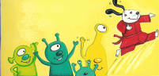
Bill cooks, does kung fu
and plays with the aliens.
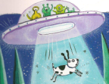
The aliens fly Bill back down on earth.
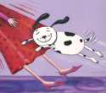
Bill sees and hugs Mrs. Pickle.
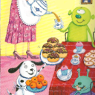
Bill keeps busy with Mrs. Pickle.

Appendix 4C-Correction Key
Bill is bored.
Bill goes for a walk with Mrs. Pickle.
The wind lifts Bill and Mrs. Pickle from their feet.
Bill lands on a strange purple planet
and meets aliens.
Bill is bored and misses Mrs. Pickle.
Bill cooks, does kung fu
and plays with the aliens.
The aliens fly Bill back down on earth.
Bill sees and hugs Mrs. Pickle.
Bill keeps busy with Mrs. Pickle.

