Writing
Boot Camp

From secondary 1 to secondary 5

Writing exercises
with the Progression of Learning (POL)
in mind



Goals of the Writing Boot Camp

- To allow students to write short texts throughout the year and practice specific grammar points.

- To enable students to recognize, name and explain their mistakes and to correct them.

- To help students become more autonomous when self-correcting their written work.

- To lower the number of grammar mistakes in students’ written production.

How this tool works

Step 1 Students will write a short text (5 sentences). This short text aims to practice specific grammar points (in general 2 or 3).

Please note that:
- A minimum of six short writing tasks are suggested throughout the year.
- It is suggested to teach the grammar points before you assign the writing tasks.
- Suggestions of texts and grammar points are given from secondary 1 to secondary 5 with the Progression of Learning (POL) in mind. See charts provided.
- These tasks are meant to practice writing and not to evaluate writing. These writing tasks are separate from the written productions that you will assign throughout the year.

Step 2 Teacher corrects texts using the codes from the Correction Code Sheet.
Teacher corrects all the mistakes.

Step 3 Student receives corrected copy by teacher and rewrites the text without the mistakes with the help of the Correction Code Sheet and Summary of my Mistakes Sheet.

Step 4 Students keep their writing samples in a section of their English binder entitled Writing Practice (or Writing Boot Camp!). This will allow them to see their progression throughout the year.

What material do students need?

A section in their English binder where they can put:
- the Correction Code Sheet (make photocopies)
- the Summary of Mistakes Sheet (make photocopies)
- the writing samples
- a photocopy of a specific appendix when needed

How do you introduce the Writing Boot Camp to students?

Class 1 - Explain to students how it works

- Introduce the concept of learning from your mistakes. Read Goals on the first page of this document.
- Ask students to write 2 or 3 sentences on this topic: What did you do this weekend? Ask student to write using the Simple Past.
- Take one of your students’ text (one where you know you will find mistakes) and write this sample of the board. If you do not feel comfortable using a student’s text as an example, invent a short 2-3 sentence text that has mistakes related to the simple past.
- Handout and explain Correction Code Sheet.
- Correct the text on the board using the codes from the Correction Code Sheet.
- Write corrected text beneath the first one on the board.
- Handout and explain how to fill out the Summary of Mistakes Sheet.
Class 2 – Try out the first text suggestion
Start with the first text suggestion depending on the level you teach. See charts that follow. Follow the steps described on page 2.

Give clear instructions to your students especially the first times. You could also give a model for weaker students. For example:

Describe your best friend

Write double-spaced. Write a minimum of 5 sentences

Use the simple present. Include adjectives (funny, tall, black hair, etc)

Use your dictionary

My friend Mike is really nice. He has a great personality. He is funny, loves to talk to people and is always busy. He is tall and has black short hair. He likes sports cars, soccer and cooking.
Class 3 – Decide when you will assign a new writing task.

How often should I assign writing tasks ?

You should do a minimum of six productions during the year so students get a chance to work on their mistakes.

Other advantages of using the Writing Boot Camp

- The Writing Boot Camp can be used as a portfolio to keep written productions and to see the improvements as the year progresses;

- The Writing Boot Camp can be used at parents’ meeting to show the work that has been done by students;

- The Writing Boot Camp helps teachers to plan remedial classes based on areas where a student or a group of students need more help;

- The Writing Boot Camp is already used by many French teachers (Le Profil de Scripteur) therefore students will increasingly develop these strategies and reinvest them in other areas of their studies.

Going beyond

If you wish to do more writing with your students, a list of creative writing ideas is given at the end of this document. See Final Appendix.

Before starting with your students

Read this booklet a few times to get acquainted with the procedure and get familiar with the different appendices.

This document was written by teachers of the St-Hyacinthe school board: Chantal Breton, Karine Hissoiny, Jacques Lacharité and Laurent-Antoine Lussier.

Tanja Vaillancourt, Pedagogical Advisor CSSH, revised by Isabelle Giroux, CSRDN
Creative Writing ideas: Tanja Vaillancourt and Isabelle Giroux

It was inspired by :
Profil de Scripteur (Louise-Isabelle Couture, 1999)
Guide d’aide à l’implantation et à l’organisation de la démarche Profil de Scripteur dans une école (Louise-Isabelle Couture CSRDN, Christian Tavernier CSRDN et Lynda Côté, CS des Affluents, Services des ressources éducatives, 2010)
Document written by:
Claude Ouellet, Pedagogical Advisor

Correction Code Sheet

CODE | MISTAKES | EXAMPLE | CORRECTION | WHERE I CAN GET HELP
VT | Verb tense | Yesterday, we come. | Yesterday, we came.
SVA | Subject/verb agreement | She drink a lot of coffee. | She drinks a lot of coffee.
WO | Word order | He drives a car small. | He drives a small car.
SP | Spelling | I thougth I had more money. | I thought I had more money
PR | Pronouns | He is speaking with she. | He is speaking with her.
??? | Meaning unclear
P | Plural | He ate two tomatos. | He ate two tomatoes.
P/C | Punctuation  /capitalization | She will visit on sunday | She will visit on Sunday.
PA | Possessive adjective | It is yours book. | It is your books.
AR | Article | The Canada is a rich country. | Canada is a rich country.
WW | Wrong word | He is listening TV. | He is watching TV.
MW | Missing word | Where he live? | Where does he live?
TMW | Too many words | I am go to the hotel. | I go to the hotel.
T | Translation | Cup you! (tasse-toi) | Move over.
FW | French word | I assisted the conference. | I attended the conference.
POSS | Possessive case | It is the book of my brother. | It is my brother’s book.
PREP | Preposition | I will meet you Monday. | I will meet you on Monday.
C/S | Comparative/superlative | I am more big than you. | I am bigger than you.
CONJ | Conjunction | I ate a cookie for I was hungry. | I ate a cookie because I was hungry.
TW | Transition word | He will fail his year. He did not study. | He will fail his year because he did not study.
MOD | Modal | He would study for his exam. | He should study for his exam.
ADV | Adverb | He speaks soft. | He speaks softly.
TS | Tense shift | We baked a cake and eat it. | We baked a cake and ate it.
PV | Phrasal verb | I have to care my sister | I have to take care of my sister.

Summary of my Mistakes Sheet

CODE | MY MISTAKE | CORRECTION | RULE
 |  |  | For example : Grammar Book page 5

Secondary 1
- Write 5 sentences.

 | Text Suggestion | Focus on Form
1 | WHAT I DO EVERYDAY (between 7:00 and 8:00 in the morning. Eg : I eat breakfast when I wake up…)  and  WHAT ANOTHER PERSON DOES EVERYDAY | - simple present  - subjects pronouns (3 different ones : I, She, He, It)
2 | DESCRIBE THE PICTURE  (Man, Woman, Animal)  - See Appendix 1 ( feel free to change the choice of pictures) | - to be/to have present  - possessive adjectives
3 | DESCRIBE A CRAZY CAFETERIA | - there is/are  - a / an  - numbers 10 to 100 (3 numbers)
4 | YOUR BEST CHRISTMAS | - simple past (there was/were)  - transition words
5 | INTERVIEW YOUR FAVOURITE STAR | - simple present  - simple past  - yes-no questions (2)  - Information questions (2)
6 | AN IDEAL WEEKEND | - future  - plurals  - adjectives

Secondary 2

- Write 5 sentences.

 | Suggestion of text | Focus on Form
1 | DESCRIBE YOUR BEDROOM | - simple present  - plurals  - preposition
2 | WHAT I BOUGHT AT THE SHOPPING MALL | - comparatives/superlatives  - simple past  - prices (numbers written in letters)
3 | A PLACE YOU WANT TO TRAVEL TO.  (Use your five senses to describe your trip.) | - simple future  - adjective order
4 | DESCRIBE EACH PICTURE  (5 pictures)  - See Appendix 2 (feel free to change the choice of pictures) | - present continuous  - demonstratives (this/that/these/those)
5 | I AM AT A MUSIC CONCERT | - simple present  - present continuous  - plurals  - adjectives
6 | DREAM SUMMER | - possessive case  - simple future  - prepositions

Secondary 3
- Write 6 sentences (Text types are being introduced in secondary 3)

 | Text suggestion | Focus on Form
1 | YOUR SCHOOL, YOUR RULES  Write an e-mail to your principal | - imperative(always, never, do not+verb, no + noun, no + verb + ing)  - prepositions  - articles (the vs nothing)
2 | A HORROR SCENE  Write a description  It was Halloween night and… | - past continuous  - adjective order  - possessive case
3 | INTERVIEW A FICTIONAL CHARACTER  Write an interview | - simple present  - simple past  - simple future  - information questions
4 | ADVERTISEMENT (two cars, two cell phones, two restaurants, two celebrities,…)  Write an ad | - comparatives/superlatives  - simple present  - transition words (2) : but, therefore…
5 | HOW TO BE A BAD CLOWN (teacher, student, employee, ….)  Write instructions | - conditional (would, should, could)  - adverbs  - object pronouns
6 | I AM AT THE BEACH  Write a postcard  Impose a mood: romantic, funny, sad, scary,… | - simple present vs present continuous  - transition words (conjunctions)

Secondary 4
- Write 6 sentences.

 | Suggestion of text | Focus on Form
1 | EXTREME PERFORMANCES  Write a description  Eg: Guinness record, sport event, contests…  You are the journalist: Describe what you are seeing. | - present continuous  - prepositions (in, on, at)
2 | OBITUARY  Write a description  How will people remember you OR how would you like to be remembered? | - simple past  - possessive case  - adjectives
3 | NATURAL DISASTER  Write an interview | - past continuous  - simple past  - simple present  - simple future
4 | PHOTOSHOP: IS IT REALLY NECESSARY?  Write your opinion  - See Annex 3  - And watch Dove video :http://www.youtube.com/watch?v=iYhCn0jf46U | - comparatives and superlatives  - conditional (modals)
5 | WORST CASE SCENARIO  Write a story  You take off with your parents’ car for the first time… | - simple present vs. Present Continuous  - Time markers
6 | CRAZY OR REAL ADDICTION  Write a diary  Anecdotes and consequences | - Simple Present  - Present Perfect

Secondary 5

- Write 6 sentences.

 | Text Suggestion | Focus on Form
1 | INTERVIEW THE PERSON YOU WILL BE WHEN YOU WILL BE 30 YEARS OLD  Write an interview  Three questions and three answers | - questions words  - simple present  - simple past
2 | JOB INTERVIEW  Write instructions  How to have the perfect or worst interview | - modals  - adverbs
3 | YOUR FAVOURITE MOVIE  Write a summary  Looking at a picture, students write the synopsis of a movie that doesn’t exist.  - See Appendix 4  - (feel free to change the choice of pictures) | - simple present  - future  - demonstratives (this, that, those, these)
4 | A NEW LAW  Write an opinion  What is you could drive with your friends and could not drive at night until you are 21? | - modals  - connectives (first, second, third)
5 | INVENT THIS PERSON’S LIFE  Write a description  - See Appendix 5  - (feel free to change the choice of pictures) | - simple present  - present continous
6 | PROM: HEAVEN OR HELL  Write a personal story | - direct / indirect speech  - adjectives

Appendix 1 – SECONDARY 1 – DESCRIBE THE PICTURE
Describe these people and this dog.

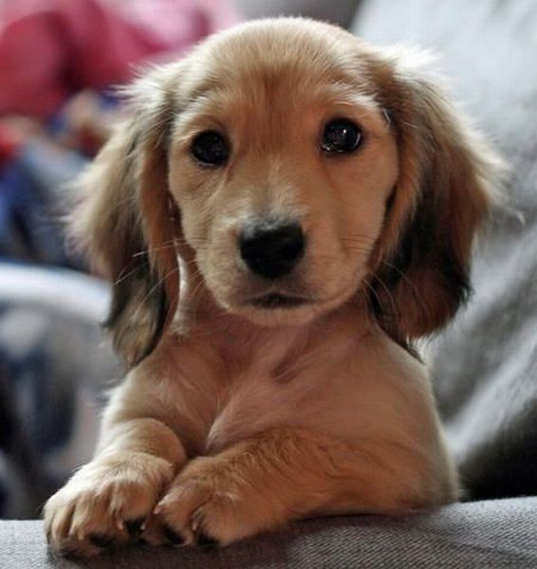



Appendix 2 – SECONDARY 2 - DESCRIBE THE PICTURE

- Choose 5 pictures that you will describe

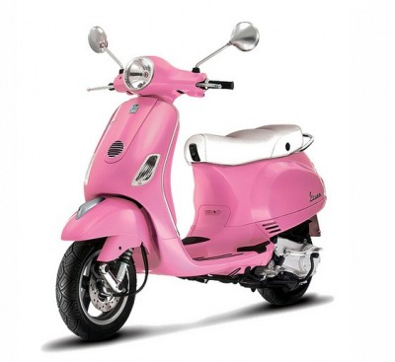 |  | 
 | 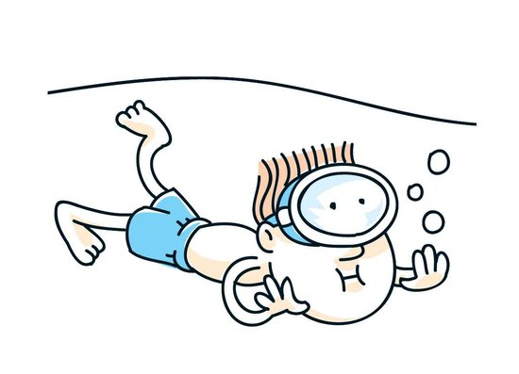 | 

Appendix 3 – SECONDARY 4 – PHOTOSHOP AND PLASTIC SURGERY. IS IT REALLY NECESSARY?

Before and After

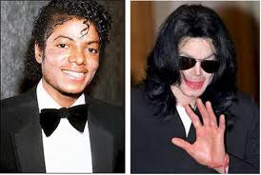

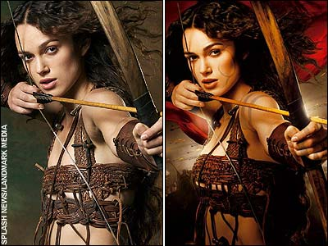

Appendix 4 – SECONDARY 5 – YOUR FAVOURITE MOVIE
Look at this picture and invent the summary of a movie it is related to.

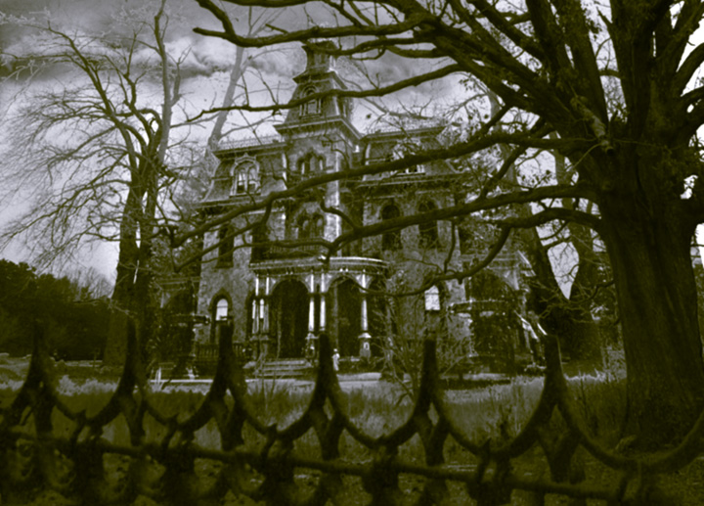

Appendix 5 – SECONDARY 5
Invent this person’s life.



FINAL APPENDIX
EXTRA IDEAS – EXTRA IDEAS – EXTRA IDEAS – EXTRA IDEAS –

-FOR THE TEACHER- Creative Writing

If you want your students to develop the love of writing try out these creative writing ideas:

1. Wave writing:

Listen to the music, let your imagination go wild, write on the waves, look at the pictures and answer these questions:

  - Where are you?
  - How is your neighbour’s towel?
  - What about the girls in the bikinis?
  - The ice cream guy is shouting again. What is he saying?
  - What are you doing besides sun tanning at the beach today?
  - What are you doing tonight?

2. Speed writing.

Your hand must never stop for 2 minutes in a row. Never stop! Never stop! If you don’t know what to write repeat the same word over and over again until you find an idea. Your text could look like this: “This weekend, I went out the cinema, cinema, cinema, cinema. I was with my friend Johanne. She ate popcorn, and I bought candies, candies, candies…”

Then, rewrite your entire text without the repetition.

These will be your first ideas to start writing a text.

3. Write to music. Listen to the music: Rock, classical, Rap, etc. Make a tape this weekend and try it out next week with your students.

Prompt: She turned around and saw the look on his face…
Music #1 | Music #2 | Music #3

4. A story to finish. Choose silly sentence starters.

My neighbour has a pink cat …

5. Impose a mood for a text Example: What are your plans for the weekend? Talk about them using one of the following mood: Excited, thrilled / angry / sad / Bored / Worried

6. 5 Strips of paper. Students receive 5 blank strips of paper. On these papers, they write their answers to questions the teacher will ask. (For example: What did you eat this morning? What is your favourite country? How do you feel today? What is the last thing you bought? What’s your favourite colour?) Collect strips of paper, mix them up and pass them out again. Students now have new answers to start writing.

7. Add your own ideas:

Experiment with a variety of texts

Popular :
Email  Greeting card  Comic strip  Invitation | Letter  Postcard  Song

Literary :
Biography  Drama  Fantasy  Fiction  Diary  Legend | Myth  Mystery story  Poetry  Science-fiction  Teen play

Information-based:
Advertisement  Announcement  Application  How to …  Label of a product  Instructions  Memo | Menu  Newspaper article  Multimedia presentation  Questionnaire  Report  Schedule  Sign


Progression of Grammar Knowledge – 1st cycle
(POL list elaborated by Commission Scolaire Du Fer)

Knowledge | Sec.1 | Sec.2
Sentence structure  - Simple sentence  - Complex sentence  ⇒Transition words | Subject + verb+ object  (rest of the sentence)  Some transition words :  First And  Second Or  Third But, etc.  In addition | Subject + verb+ object (rest of the sentence)  Some transition words :  First Also  Second Or  Third But  And In addition, etc.
Question words  Wh question words | Who Why  What Which  Where How much  When How many  How | Who Why  What Which  Where How much  When How many  How
Word order  - Adjectives | Adjectives  - position before noun  - invariable  Two blue balloons | Adjectives  - adjectives order  It is very unusual to have more than three adjectives.  Follow this order :  number– opinion- size – shape – age – color- origin + NOUN  Ex:  - Five tasty red apples.
Verbs  - Tenses and modes  - Sentence types  - 3 main auxiliaries  - Modal auxiliaries  - Gerunds | Tenses and modes in all three sentence types  - Simple present  - Simple past  - Simple future  - Present continuous  - Imperative  Sentence types  - Affirmative  - Negative  - Interrogative  3 main auxiliaries  - To be  - To have  - To do  Modal auxiliaries  - Will  - Can | Review year 1 if needed  +  Simple present  - Emphasis oral pronunciation of “s” ending  Ex: He loves [z], watches [ez], helps [s], etc.  Simple past  - Emphasis oral pronunciation of “ed” ending  Ex: I walked [t], I visited [ed], rained [d]  Some new modals such as :  - May  - Must  - Have to
Vocabulary | - Prefix-suffix  - Serious-seriously  - Theme related vocabulary and idiomatic expressions  - Some phrasal verbs  (Sit down, Wake up, Watch out, etc.) | - New theme related vocabulary and idiomatic expressions  - New phrasal verbs

Progression of Grammar Knowledge – 1st cycle (continued)

Knowledge | Sec.1 | Sec.2
There is / there are  There was / there were | There is / there are  There was / there were | Review year 1 if needed
Punctuation | . ! ? : , | Review year 1 if needed
Capital letters | - First word of the sentence  - (I)  - Proper nouns  - Days, months, holidays  - Names of places  - Languages and nationalities  - Name of religions | Review year 1 if needed
Plurals including exceptions | Consonant+Y = ies  Sh, ch, x, o, s = es  Some exceptions :  Ex : mouse, mice  Foot, feet | Review cycle 1 if needed
Articles | A, an, the | This Those  That These
Prepositions | Frequently used prepositions  For example :  - Location  On, in, at  - Time  On, in, at  - Direction  Left, right, etc.
Pronouns et possessive adjectives  Types  - object (Me)  - possessive (Mine)  - subject (I)  - reflexive (Myself)  - indefinite (Somebody)  - relative (Whom, who, whose, which) Coherence | - object (me)  - subject (I) | - possessive (Mine)  - indefinite (Somebody)  - reflexive (Myself)
Contractions oral/written | Contractions oral/written  - You’re/you are  - don’t /Do not  *Let them know that they exist but need to be used in proper contexts.
Possessive  ’s | Possessive  ’s  My mom’s castle  Two boys’ bikes
Comparative/superlative  Quantitative adjectives | - Quantitative adjectives  Many, few, five, several, etc.  - Comparative  More than/less than  - Superlative  Big, bigger, biggest | Review cycle 1 if needed

Progression of Grammar Knowledge – 2nd cycle

Knowledge | Sec.3 | Sec.4 | Sec.5
Sentence structure  - Simple sentence  - Complex sentence  ⇒Transition words | Subject + verb+ object (rest of the sentence)  Some transition words :  Nevertheless  However  Therefore | Subject + verb+ object (rest of the sentence)  Some transition words :  In contrast  Similarly  Moreover | Subject + verb+ object (rest of the sentence)  Some transition words :  In contrast  Similarly  Moreover
Direct (quoted) speech  Indirect (reported) speech |  | Direct (quoted) speech  Indirect (reported) speech  Examples  Direct (quoted)  Jim said : « I am sleepy »  Indirect (reported)  Jim said that he was sleepy. | Review sec. 4
Question words  Wh question words | Review 1-2 if needed | Review 1-2 if needed | Review 1-2 if needed
Word order  - Adjectives | Review 1-2 if needed | Review 1-2 if needed | Review 1-2 if needed
Past participle with different uses  - Passive  - As adjective with to be  - As adjective with to get | - Passive  - I was surprised by the news.  - As adjective with to be  - Paul is frightened.  - As adjective with to get  I get confused. | Review 3 if needed | Review 3 if needed
Verbs  - Tenses and modes  - Sentence types  - 3 main auxiliaries  - Modal auxiliaries  - Gerunds | Review year 1-2 if needed  New tense in all three sentence types  - Past continuous  Some modals such as :  - Could  - Should  - Might  - Would | Review 1-2-3 if needed  New tense in all three sentence types  - Present perfect(past participle)  Optional: depending on group strength.  If + conditional  All modals  - Gerunds  I stopped to smoke/I stopped smoking | Review 1-2-3-4 if needed  The rest of the verb tenses if you can, including:  - Present perfect  (past participle)  - Future continuous
Vocabulary | - New theme related vocabulary  - Cognates  (true and false)  False : Emission/emission  True : Table/table  - New phrasal verb | - New theme related vocabulary.  - New phrasal verbs | - New theme related vocabulary  - New phrasal verbs

Progression of Grammar Knowledge – 2nd cycle (continued)

Knowledge | Sec.3 | Sec.4 | Sec.5
 | Review year 1  + There will be | Review year 1 and 3 if needed | Review year 1 and 3 if needed
Punctuation | Review year 1 if needed | Review year 1 if needed  +  Quoted speech  said , « yes » | Review year 1 and 4 if needed +  ;
Capital letters | - Title used with the names of people: Dr. Smith.  - Names of courses (Chemistry 101)  - All of the important words of a title | Review year 1-3 if needed | Review year 1-3 if needed
Plurals including exceptions | Review cycle 1 if needed | Review cycle 1 if needed | Review cycle 1 if needed
Articles | Some  Any
Prepositions | More prepositions.  See provided list
Pronouns and possessive adjectives  Types  - object (Me)  - possessive (Mine)  - subject (I)  - reflexive (Myself)  - indefinite (Somebody)  - relative (whom, who, whose, which) Coherence | - Coherence  - Example :  Parents should take care of his their children | - Relative (whom, Who, whose, which)
Contractions oral/written | Using contractions in appropriate contexts. | Explore formal/informal language.  - gonna / going to*  - wanna / want to*
Possessive
’s
Comparative/superlative  Quantitative adjectives | Review cycle 1 if needed | Review cycle 1 if needed | Review cycle 1 if needed

Progression of Verb Tenses knowledge -1st and 2nd cycle
 | Present | Past | Future
Simple | Sec 1-2  I love  You love  He loves  We love  You love  They love | Sec 1-2  I loved | Sec 1-2  I will love
Continuous  - To be + ing | Sec 1-2  I am loving  You are loving  He is loving  We are loving  You are loving  They are loving | Sec 3  I was loving  You were loving  He was loving  We were loving  You were loving  They were loving | Sec 5 *  I will be loving
Perfect  - To have + past participial | Sec 5  I have loved  You have loved  He has loved  We have loved  You have loved  They have loved | Sec 5  I had loved | Sec 5 *  I will have loved
Perfect continuous | Sec 5*  I have been loving  You have been loving  He has been loving  We have been loving  You have been loving  They have been loving | Sec 5*  I had been loving | Sec 5*  I will have been loving
*Optional

List of Time Prepositions |  | List of Place Prepositions |  | List of Direction Prepositions
after  around  as  before  between  by  during  for | past  since  until  with  within  since  until  within | Aboard  Above  on top of  Across  Againstopposite  Around  At  at the back of  underneath  between  at the bottom of  near  at the top of  next to | to the left of  behind  to the right of  below  on  by  in  inside  outside  under  on the corner of  on the side of  on the other side of  in the middle of | from  left  over  right  through  under
In this grid you will find the grammatical notions to be taught within a year for each level. However, you may not be able to teach every grammatical notion pertaining to each level.

Be realistic. Do your best!
NB

