Appendix 7

My Lost and Found Mini-book

Writing a personalized text

Instructions
Page 1:  Write your name.  |   Page 2:  Choose 2 colours and 1 description.
  Colour | Description
  - pink  - grey  - black  - white  - yellow | - round  - cute  - funny  - big  - small
For page 3.  It’s my turn.  I am paying attention!  Repeat colour and description from page 2.  For page 4. Choose an action word.    - crying  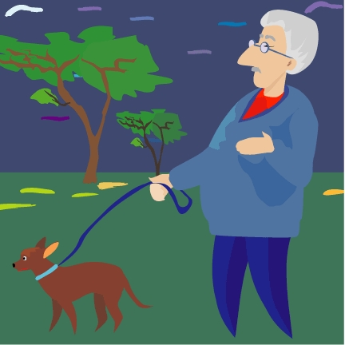  - wandering    - sleeping    - hopping    - waddling | For page 5: Choose a different animal    For page 6: Repeat your page 2.    Draw the pictures in the boxes.  Cut out your mini-book.  Present your mini-book to a friend or a family member.  
Writing My Mini-book
1.  I’ve Lost My Cat  By: ____________________________  (1) | 2.  I’ve lost my cat. He’s  _______________ , ____________ and  (2-colour) (2-colour)  ____________________________.  (2-description)
3.  I’ve found your cat, all  _______________ , ____________ and  (2-colour) (2-colour)  ____________________________.  (2-description) | 4.  He was  ____________________________.  (3-action)

5.  That’s not my cat. That’s a _________________________________!  (4-animal) | 6.  I’ve found my cat, so  _______________ , ____________ and  (2-colour) (2-colour)  ____________________________.  (description)
7.  It’s time to sleep. Good night! | 8.  The end

