Station 1

I Like, I Don’t Like

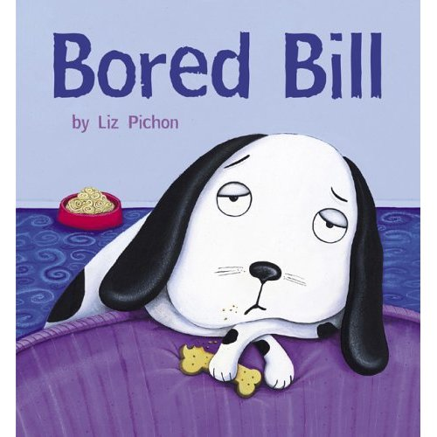



Teacher’s Instructions
STATION 1: I like, I don’t like

- 4 plastified Appendix 1A “I like, I don’t like” sheet
- 4 envelopes (labeled #1) including the Appendix 1B “Activities” sheet
- 4 pencils
- 1 Appendix 1C “Cards” per student to be place in another envelope (labeled #2).
- Wool or glue
- scrapbook/duo tang

- Each student in the station takes one sheet and one envelope (envelope#1).
- Students individually must place each strip of paper found in the envelope in the appropriate column “I like, I don’t like”.
- Students share with their teammates their likes and dislikes.
-Help students with their functional language by modeling “I like, I don’t like”
e.g. I like going for a walk. I don’t like playing soccer.

- Students take a “card” in the envelope (envelope#2).
- Students choose one thing that they like, and one thing that they don’t like from the activity strips proposed.
- Students write their choices on the card.
- Students can either attach the card around their neck with string or glue it in scrapbook/duo tang.
- When students are finished, they place the strips of paper back in the envelope 1. Tell students that there should be 14 in total.

If students finish early, invite them to go to the station 7 “When I’m Finished” Station.

Students are ready to go to the next station.

Station 1-Student Instructions:

- Take one sheet and one envelope per student.

  I like |   I don’t like


=
+

- Place on the sheet the strips of paper if you like or not the activity.
I like | I don’t like  playing soccer
 | 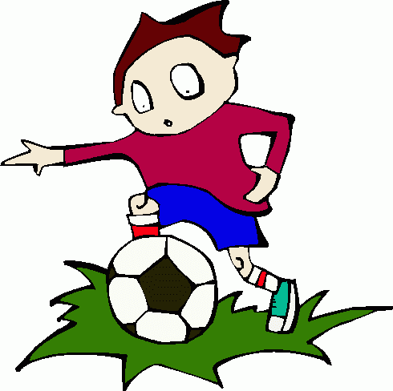

I like
_____________


I don’t like
_____________

- Write one activity you like and one activity that you don’t like.


+

Appendix 1A: I like I don’t like.
I like | I don’t like

Appendix 1B: Activities Make 4 copies. Cut, plastify and place in 4 different envelopes.
playing soccer |   going for a  walk
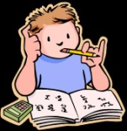  doing homework | 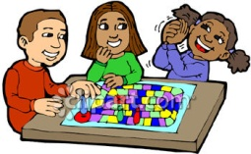  playing board  games
gardening |   watching T.V.
  Kung Fu |   reading a  book
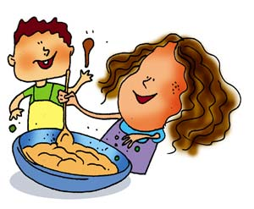  cooking with mom/dad | 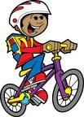  biking
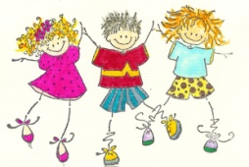  dancing | 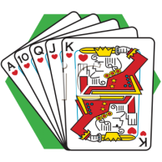  playing cards
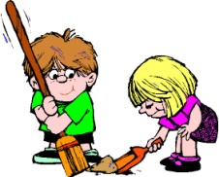  cleaning | 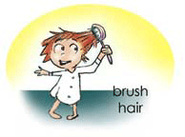  brushing my  hair

Appendix 1C: Cards
Make one copy per student. Make holes. Place them all in one envelope (envelope labeled # 2).
I like
_____________

I don’t like
_____________

I like
_____________

I don’t like
_____________

