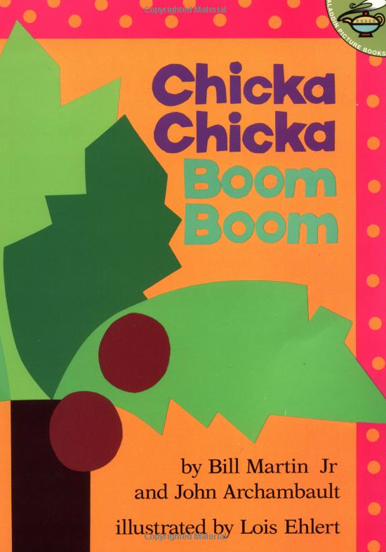
Reading Kit

Included in this kit:
  - Alphabet and image cards
  - Scene paper
  - Coconut photocopy

Chicka Chicka Boom Boom
  - By Bill Martin Jr
  - And John Archambault
  - Scholastic

Activities:
  - 1. Visit this link to hear the song: http://youtu.be/4QdN-HYp46c
  - 2. Find this page in the book and recreate the scene with the alphabet letters. Name the letters in English as you place them.
  - 3. Associate the letters of the alphabet with the image cards.
  - 4. Cut and colour the coconut tree to recreate a page from the book. Glue on the green paper and present to class.

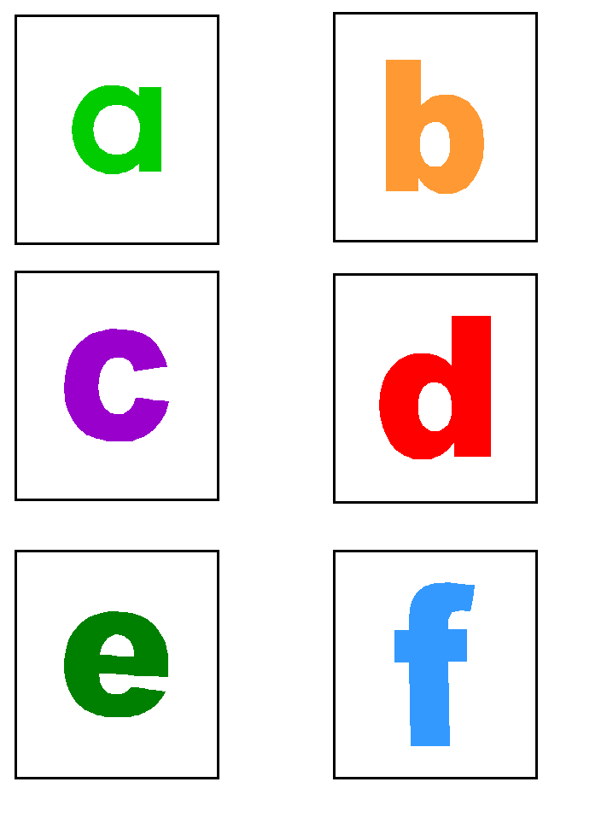

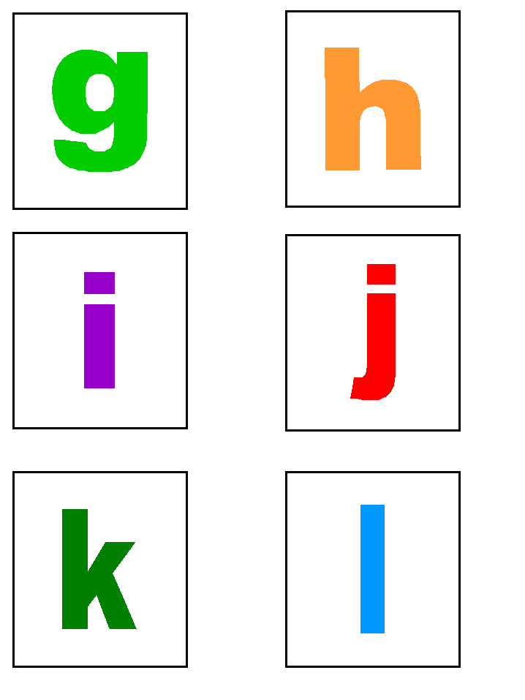

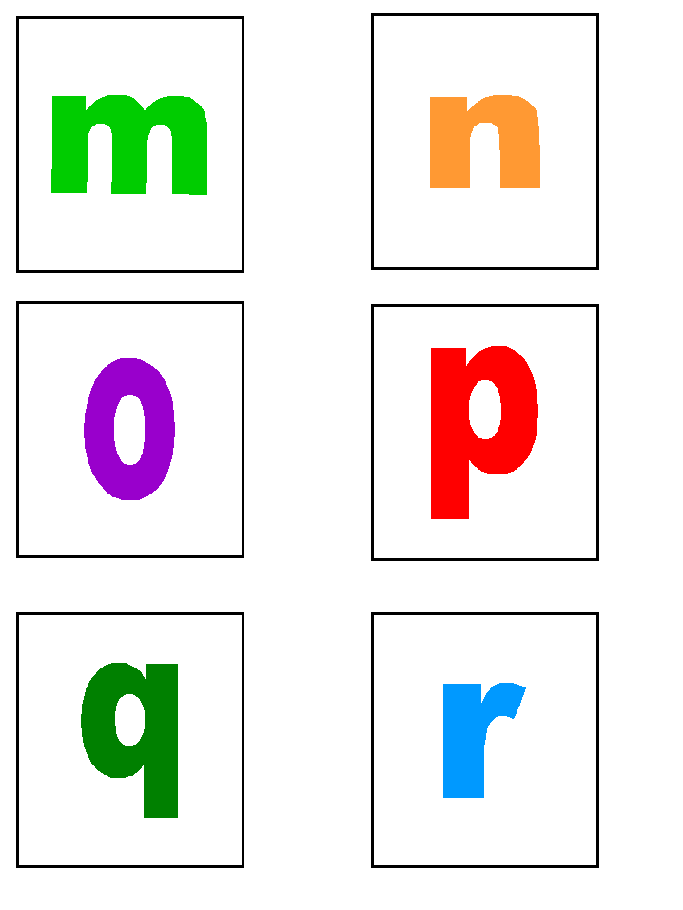

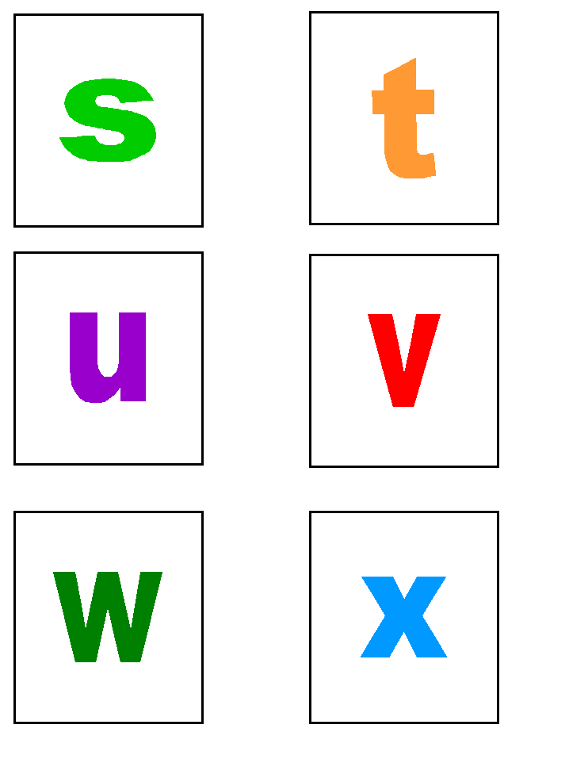

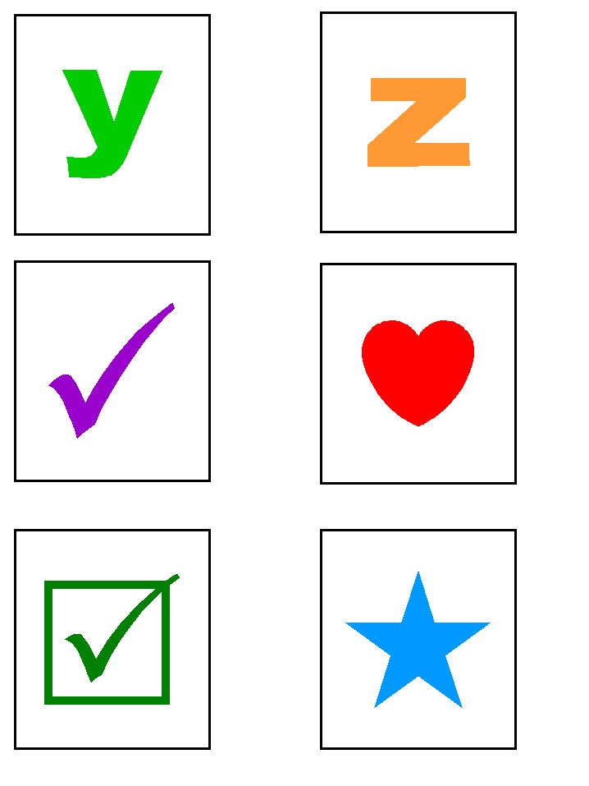
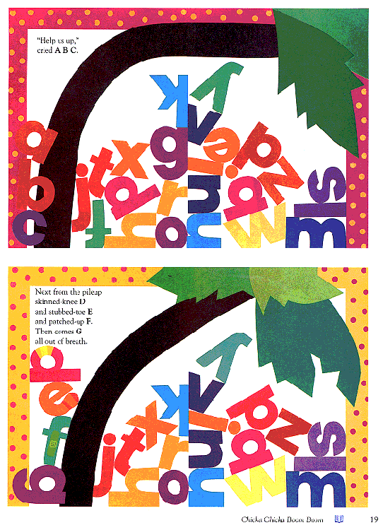

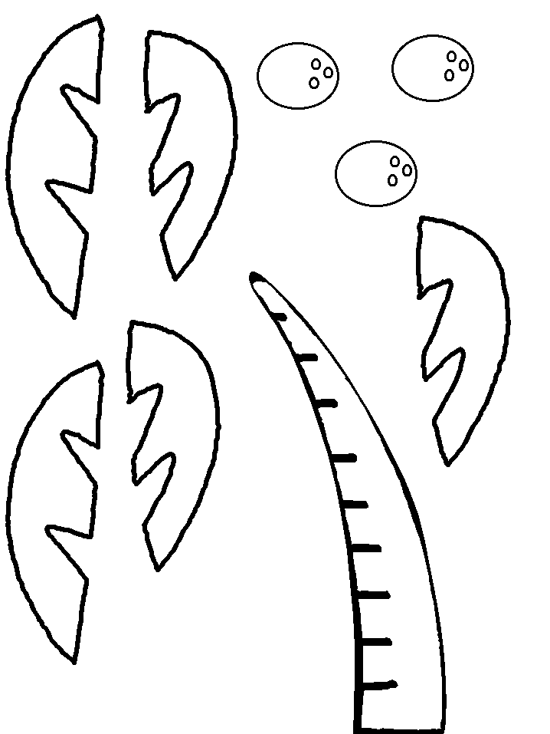
Instructions
Colour, cut and glue all the pieces on the green paper. Add some letters to recreate a page from the book.

