Station 5-
Boardgame
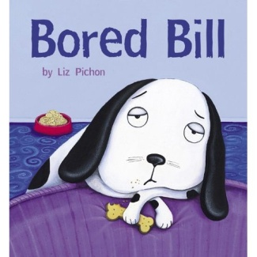



Teacher’s Instructions
STATION 5: Bored Bill and Friends Boardgame
Material:
- 1 plastified Appendix 5A- boardgame
- 4 tokens
- 1 die
- 1 Appendix 5B-Cue Card Tent (functional language and words to song)
- Posters (Appendix TG2 in Teacher’s Guide)

Students will be playing a boardgame (to be plastified). Place four tokens, a die and the visual cue card tent on the table, for students to consult as they play along.
- Students place their tokens on ‘Start’.
- The shortest student starts the game by rolling the die. The student then moves the number of spaces indicated on the die.
- The student must do what is written on the space. When students fall on the “Bill likes” spaces, they must supply the word. Model an example to students before beginning the Stations.
Bill likes

Example:

= Bill likes cooking.

- When the answer is correct, the student remains on the space and it’s the next student’s turn to play.
- The first student to reach the last space indicating ‘You win!!’ wins the game.
- Students can play more than once if they have time.

Answers: Paw Prints = 26 Dog treats = 17

If students finish early, invite them to go to the station 7 “When I’m Finished” Station.

Students are ready to go to the next station.

Students Instructions:


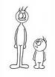
- Go to Start.

- The shortest player starts the game.

- Roll the die and move token. =+3

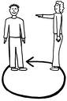
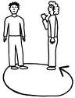
- Do what is on the space.

- Take turns.

My turn. Your turn.

- ‘You win!!’ =

- Play again.

