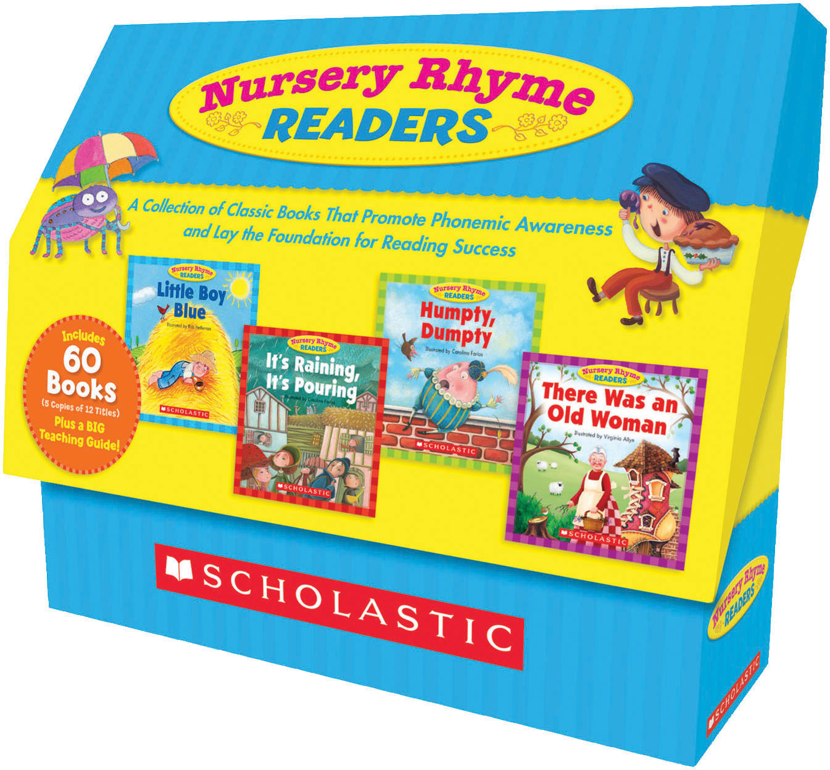
Nursery Rhyme Readers
Grade 2

The term nursery rhyme is used for "traditional" songs for young children in Britain and many other countries, but usage only dates from the 19th century and in North America the older ‘Mother Goose Rhymes’ is still often used.^{[1] Reference: Wikipedia}
This Nursery Rhyme Readers kit is a pedagogical tool for grade 2 teachers and students. For each title, a student logbook, flashcards, and different tools are proposed.
There are different possibilities to use these books.
- Individual work
- As a whole class activity
- Reading Circles or Cooperative Reading (in teams)
- Enrichment corner “When I’m Done Activity” (individual or in teams)
- Station or Centres (in teams)
- Family activity (where book is sent home with the student logbook)
Material needed:
- Nursery Rhyme Readers kit (12 titles, 5 books of each + Teaching Guide) Scholastic
- ISBN: 13:978-0-25020-x
- Student Logbook one for each title
- Checklist
- Flashcards
- Extra activities
- Teaching Guide

Suggestions:
- Number all books from 1-12. Each title is identified with A-B-C-D-E
  - Eg. Humpty Dumpty 1-A, Humpty Dumpty 1-B, Humpty Dumpty 1-C, Humpty Dumpty 1-D and Humpty Dumpty 1-E
- If books are sent home, place them in Ziplocs.
- Post checklist on wall, have students check the titles they read.
- A few extra activities to print out, cut and place in Ziploc/envelope.
- Provide certificate when students have read all 12 titles with provided example in the Teaching Guide p. 48. Use Teaching Guide for further ideas.
Nursery Rhyme Readers
Grade 2

