1

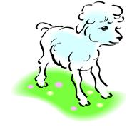
Mary Had a Little Lamb

Student Logbook
Name : ______________
_{Group: ___________}

Mary Had a Little Lamb

Mary had a little lamb
with fleece as white as snow.
And everywhere that Mary went,
the lamb was sure to go.
He followed her to school
one day,
which was against the rule.
It made the children laugh and
play to see a lamb at school.

Task : Match the words with the pictures.

the field

the pond
the library
the grocery store
the school
_{1. Write your name.}  _{2. Choose an animal.}  (hamster, cat, dog, rabbit, frog and bird)  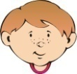  _{3. Circle: him = boy}  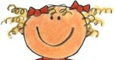  _{her = girl}  _{4. Choose a place.}  (park, pool, zoo, ice cream parlour, restaurant)  _{5. Draw a picture.} | 2  1  Marie-Eve had a little duck  2  1  Marie-Eve’s little duck followed  3  4  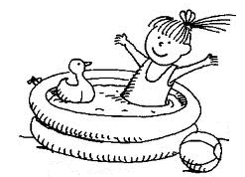  him/her to the pool.  5
Task : Let’s change version!

_{Example:}
1  ________________________ had a little _______________  2  1  __________________________’s little _______________ followed him/her  3  2  _{to the ____________________.}  4 | 5
_{My version:}

